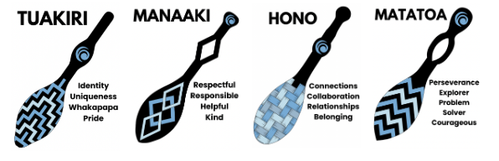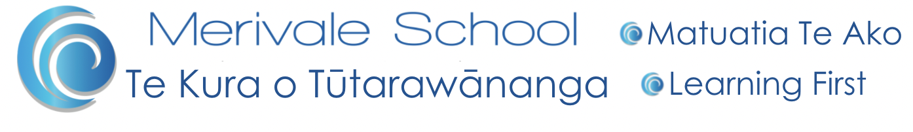

Annual Plan 2025

| Strategic Goals | Key Actions | Resources | Success Measures |
| --- | --- | --- | --- |
| Curriculum Refresh  Numeracy and Literacy  Student Achievement  Merge the NZ Curriculum refresh and TMoA redesign with our local curriculum to ensure it is cohesively and seamlessly implemented across the school.  Reading, writing and maths targets demonstrate high expectations and equitable outcomes for all cohorts and groups | NZ Curriculum Refresh and TMoA Redesign connected to Merivale School’s Local Curriculum.   * Establish Numeracy and English curriculum leaders and teams * Planning is based on refreshed and redesigned curriculum documents for teaching and learning in Numeracy/Pāngarau and Literacy/Te Reo Rangatira * Create a consistent tool/template using the new curriculum * Investigate options of assessment tools PAT and eAsttle to find the best tool for teaching and learning at Merivale School and meet the MoE directives. * Align the reporting systems and expectations of student achievement at each year level with the new curriculum phases. * Kaiako to establish knowledge rich curriculum grounded in the science of learning * Upskill pedagogical knowledge in Literacy/Te Reo Rangatira and Numeracy/Pāngarau. * Kaiako enrolled in BSLA and Rangaranga-a-tā training * Kaiako engaged in Moe PLD offered by TPKA * Kaiako begin to integrate the new resources from Maths No Problem, BSLA and Rangaranga-a-tā into their teaching and learning programmes * Kaiako continue to embed the pedagogy of BSLA into their teaching and learning programmes   Establish and ensure consistent systems and expectations to strengthen learning and teaching   * Data is collated termly and shared with kaiako and the Board * Kaiako use data to inform teaching and planning * Tier 2 Structured Literacy interventions with student groups revised after each 10 week teaching block to monitor progress * BSLA and Rangaranga-a-tā PLD for kaiako who need certification * Maths No Problem PLD | * Staff Only Days x2 from MoE for Curriculum PLD * Staff hui meeting time for Curriculum spotlights and PLD * Resources supplied from MoE for Maths No Problem * Classroom resources supplied by kura * PAT PLD * Maths No Problem PLD * Structured Literacy support time .4 (.2 MOE, .2 Kura) * PLD sessions provided by TPKA | * Evidence of agreed approaches are happening in planning and teaching practice * Teachers are confident in planning and assessing against the new curriculum and using resources * Curriculum Leaders are facilitating PLD across the school * Data reports to the Board |
| Te Mana o Tūtarawānanga  Localised Curriculum  Implement an authentic, engaging curriculum that   * reflects who we are and where we are. * focuses on the development of the unlimited potential of tamariki, staff, whanau and community * provides learning opportunities for tamariki to have new experiences, build knowledge and have ownership of their learning | Implement an authentic, engaging curriculum   * Kaiako will continue to plan, implement and review our Merivale School, Tūtarawānanga Curriculum and Te Mana o Tūtarawānanga * Embed Te Tai Whanake educational portal with a specific reference to Ngāti Ranginui Iwi * Engagement with whānau, kaumatua, hapu, iwi, community   + Student led conferences   + Cultural events   + Community events * Providing opportunities to strengthen Cultural Relations for Responsive Pedagogy (CRRP) * Providing an environment where tamariki can thrive   + School wide reward system - house tokens, certificates, recognition of achievement   + Inter School competitions and daily organised games and activities during breaks   + Celebrating and understanding cultural events   + Implementing the Healthy Active Learning Programme   + Organising EOTC trips and senior school camps * Providing leadership opportunities for Student Manukura to strengthen school culture   + Tuakana/teina - weekly support in junior classes   + Organising termly fun events   + Pals (Playground Assistance and Leadership in schools) - Sports BoP | * Te Tai Whanake Website * Tauranga Moana iwi * Taurnaga Moana Experts * Local Sights of Significance * Tūtatrawānga Localised Curriculum * TPKA (Tauranga Peninsula Kāhui Ako) * Whānau community * Visuals within our school environment | * Evidence of agreed approaches are happening in planning and teaching practice related to the Tūtarawānanga Localised Curriculum * Consistent planning templates will be utilised by all staff * High turn out to school and community events * Ambassadors and House Leaders are visible throughout our school |
| Attendance  Continuous and consistent focus on attendance for tamariki that have inconsistent attendance data | To meet or exceed the Government’s target of 80% of students regularly attending, 90% of the time.   * Ongoing gathering, comparing and reporting of data * Identify trends that may impact attendance and act accordingly * Weekly tracking of attendance categories * Using a relationships first approach fosters continued positive partnerships between whānau and kura   + Personal contact made and recorded in ETap   + Working with families to overcome challenges that impact attendance, referrals to support agencies where needed.   + Letters home to whanau showing attendance stats of chronic attenders.   + Notice and celebrate positive improvements with tamariki and whānau * Educate families about the correction between attendance and achievement on transition, through newsletter, facebook pages and whānau hui | * Funding through Tauranga Moana Attendance Services * Attendance team * TPKA Attendance officer - Liam Morrison * Tauranga Moana Attendance Services | * Term by term attendance data * Increase in the number of 100% certificates awarded * Improvements in attendance categories i.e lower percentage of chronic attenders |